

PO Box No.1, 65/67 Halifax Road, Todmorden, Lancashire, OL14 5BB, England
Tel: 01706 815737 Fax: 01706 817628

sales@penninecomponents.co.uk
www.penninecomponents.co.uk

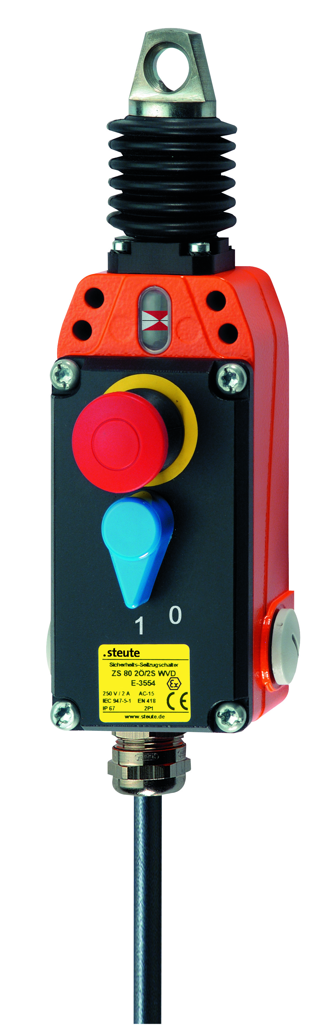
Visit our website @ www.penninecomponents.co.uk

NEW Range!

- Ex Zone 1 and 2

- Dust 21 and 22

- EEx d llc T6

- Competitively priced

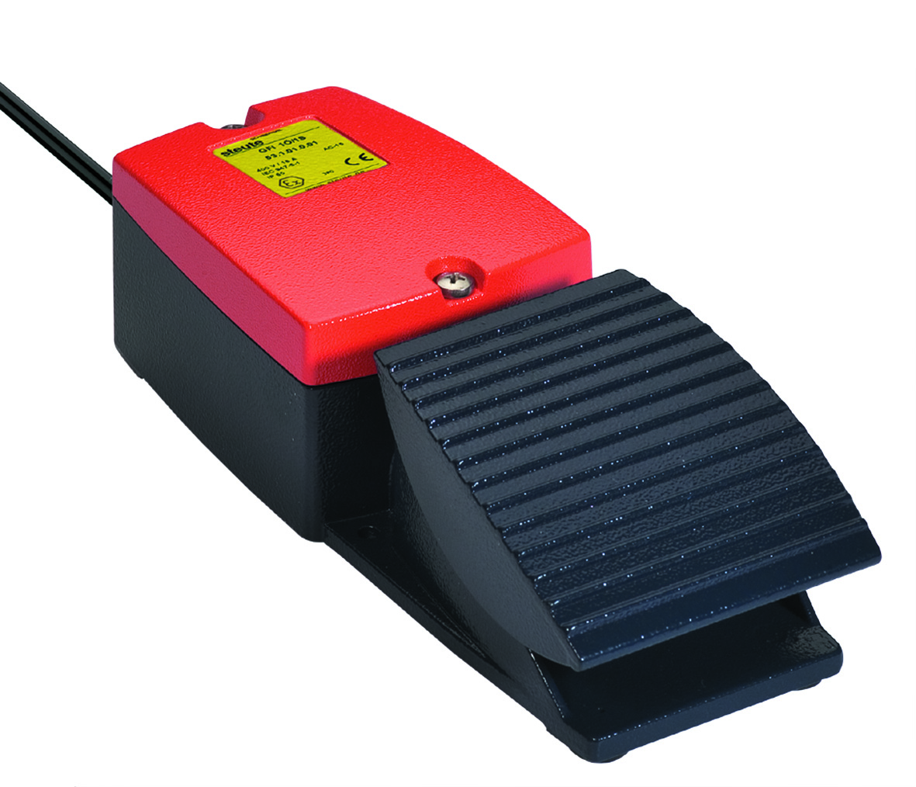
- Short Lead time

For more information on this or other Steute products please contact our sales department.

