

PO Box No.1, 65/67 Halifax Road, Todmorden, Lancashire, OL14 5BB, England
Tel: 01706 815737 Fax: 01706 817628

sales@penninecomponents.co.uk
www.penninecomponents.co.uk

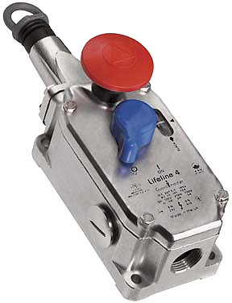
- Investment cast Stainless Steel Rope
Switch.

- Rugged, corrosion resistant 316 stainless steel construction

- Sealed IP66 / 67 enclosure

- Switches up to 75m cable span

- 2 N/C Safety Contacts, 2 N/O Auxiliary contacts

- Lid mounted emergency stop button

- Switch lockout on cable pulled and cable slack

- Cable status indicator on switch lid

- Ideal for providing emergency stop protection for conveyor systems
Visit our website @ www.penninecomponents.co.uk

For more information on this or other safety products, please contact our sales department.
Visit our website @ www.penninecomponents.co.uk

