

PO Box No.1, 65/67 Halifax Road, Todmorden, Lancashire, OL14 5BB, England
Tel: 01706 815737 Fax: 01706 817628

sales@penninecomponents.co.uk
www.penninecomponents.co.uk

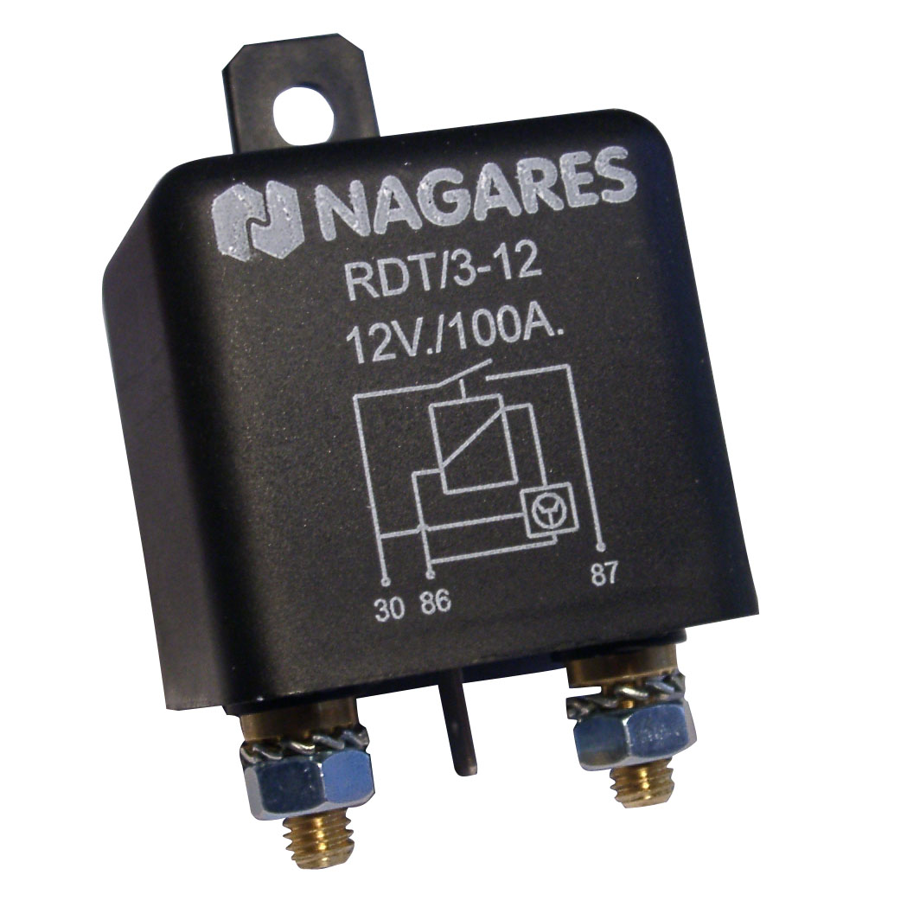
- Intelligent split charge relay.
- Monitors the voltage to detect when the vehicles alternator is charging.
- Isolates leisure batteries from cranking battery when charging source removed.
- 100A continuous rating.
- M6 terminals, plus one ¼” spade for earth.
- Factory produced reliable surface mount electronics.
- Available in 24 Vdc and 12 Vdc.

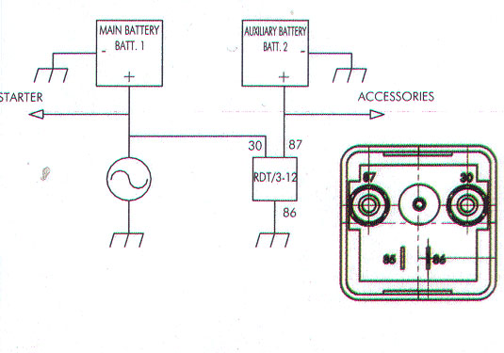

For more information on this or our other range of high current relays please contact our sales department quoting stock number 4751228 RDT3-12.
Visit our website @ www.penninecomponents.co.uk

